From: https://www.cnn.com/2021/09/12/politics/afghanistan-commanders-documentary/index.html

Top US commanders in Afghanistan wrestle with mistakes and regrets as America's longest war ends
By Nicole Gaouette, Jake Tapper and Jessica Small, CNN
Updated 8:02 AM ET, Sun September 12, 2021
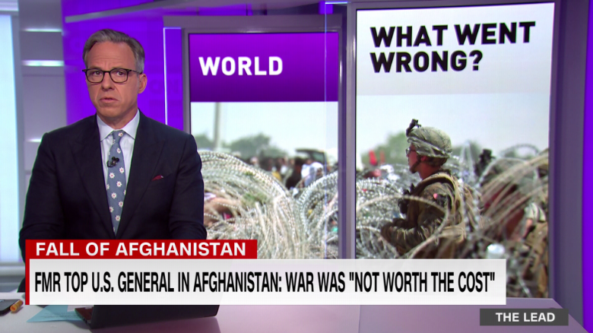
Former top US General in Afghanistan: War was 'not worth the cost' 02:38
Watch 'America's Longest War: What Went Wrong in Afghanistan' on Sunday at 9 p.m. ET on CNN
(CNN)US commanders who led the war in Afghanistan are wrestling with the country's collapse to the Taliban, with some ruing the "pretty horrible mistakes" the US military made along the way and one of them flatly declaring America's longest war was not worth the price.
"The 20-year war in Afghanistan was -- for the results that we have achieved -- not worth the cost," Karl Eikenberry, both a commander in Afghanistan from 2005 to 2007 and ambassador to the country from 2009 to 2011, tells CNN's Jake Tapper in a two-hour documentary that airs Sunday.
In "America's Longest War: What Went Wrong in Afghanistan," Tapper conducts in-depth interviews with eight US commanders who led the war effort over two decades and four administrations, and who speak with new candor about decisions made by their commanders-in-chief that they believe undermined the war effort and might have prevented its success.
In the interviews with the former military leaders and others, Tapper examines the mission and the missteps,
- how political decisions hurt the ability of service members to succeed,
- whether the Pentagon misrepresented the Afghan military's abilities to the public, and
- how after 20 years of sacrifice, the US withdrawal resulted in the return to power by the Taliban in August.
After nearly two decades and more than $2 trillion in US taxpayer funds, after the deaths of more than
- 6,000 Americans and
- 100,000 Afghans,
the bipartisan debacle that was the war in Afghanistan ended much like it began, leaving Americans -- especially those directly involved in the conflict -- struggling to understand how it all fell apart.
No longer in uniform, Gens.
- Stanley McChrystal,
- David Petraeus,
- Joseph Dunford,
- John Allen,
- David McKiernan,
- Dan McNeill, and Lt. Gens.
- Eikenberry and
- David Barno,
speak frankly.

Resentment, frustration, regret
They describe their resentment about the way politicians scaled back resources for Afghanistan to fuel the war in Iraq, their frustrations about squandered opportunities and their regrets. They question long-celebrated strategies and -- in a preview of the painful national reckoning about Afghanistan that is only just beginning -- grapple with whether the mission was worth the cost.
"My first impulse is to say, yes, it was worth it, but I no longer am certain of that," retired four-star general McNeill, who led coalition forces in Afghanistan from 2002 to 2003 and then US troops from 2007 to 2008, says. "Before I go to my grave, I hope to have that question answered."
Eikenberry observes, "There really was no clear political end state. That leads to deep questions. Was it worth it? What was it all about?"

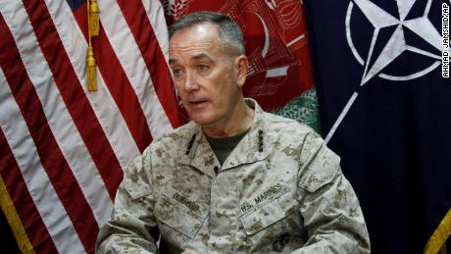
Marine Gen. Joseph Dunford, who commanded the US-led International Security Assistance Force (ISAF) in Afghanistan, spoke during an interview with The Associated Press at the ISAF headquarters in Kabul in August 2013.
Dunford says he believes the US accomplished its mission "to prevent al Qaeda from attacking the United States, to prevent Afghanistan from being a sanctuary and also mitigate the risk of mass migration."
He adds, however, "We shouldn't confuse the outcome with saying that we did that at an appropriate level of investment." He would have liked to see "fewer young men and women having lost their lives, families suffering, casualties, there's no question about it. But at the end of the day, I'm not willing to say it wasn't worth it."
The documentary also features veterans of the war -- the tiny percentage of Americans who have shouldered the risks and sacrifices to execute the mission in Afghanistan -- who share their anger about
- being trained to fight but then asked to nation-build, about
- the disconnect between political messaging out of Washington and realities on the ground, and most searingly, about
- the loss of so many comrades-in-arms, both on the battlefield and to suicide.
Diplomats and journalists who closely followed the war's fortunes underscore
- rampant corruption in Afghanistan and Trump
- administration moves that strengthened the Taliban. They also point to
- politicians who "just couldn't bring themselves to tell the truth," and give the American people a clear picture of what was really happening half a world away.

'We didn't understand'
The mistakes began before the US even entered Afghanistan, the commanders say.
"We didn't understand the problem," says McChrystal, who led international forces from 2009 to 2010. "The complexities of the environment, I think, weren't appreciated. We went for what we thought would work quickly over what would have likely worked over the longer term."
McChrystal argues that in hindsight, right after the September 11, 2001, attacks that triggered the invasion of Afghanistan, the US should have held its fire -- "no bombing, no strikes" -- though he acknowledges that would have been almost impossible. Instead, he would have spent a year building a coalition to counter al Qaeda and training Americans in Arabic, Pashto, Urdu and Dari languages "to get ourselves ready to do something that we knew would be very, very difficult."
McChrystal points out that no one was thinking in the long term, either. "I don't think we sat around a table, ever, and talked about where's this going to be in 20 years."

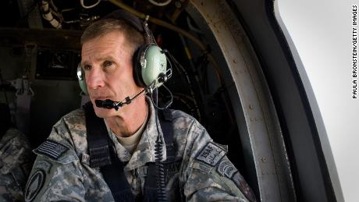
Commander General Stanley McChrystal sits in the helicopter after a lengthy conference meeting with military officials in October 2009 at forward operating base Walton, outside of Kandahar, Afghanistan.
That may be because very quickly, President George W. Bush and his administration switched their focus to a new, elective war in oil-rich Iraq -- so intensely that in October 2002, Bush didn't even know who his commander in Afghanistan was.
The commanders suggest that shift to Iraq redirected personnel and equipment away from Afghanistan that could have saved lives and potentially changed the outcome of the war.
"I personally resented the war in Iraq," Barno, the senior US commander in Afghanistan for 19 months over 2003 to 2005, says.
"Much of our strategic attention and much of our strategic capacity was diverted into Iraq, to the detriment of the [Afghanistan] war," Allen says.
Since many of the military's helicopters were sent to Iraqi front lines, combat outposts in eastern Afghanistan were placed at the bottom of valleys to make for easier resupply. That also left troops vulnerable -- surrounded by armed militants in the mountains above them.

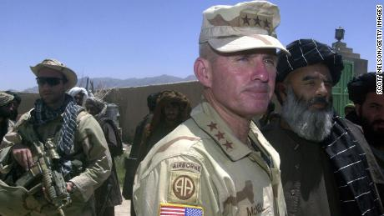
US Army General Dan McNeill, the commander of coalition forces in Afghanistan, speak to reporters in July 2002. McNeill had just met with local elders in the village of Deh Rawud in southern Afghanistan.
McNeill, the commander Bush didn't know in 2002, recalls meeting the President at the White House in 2007, during his second tour as a commander in Afghanistan. "'Tell me exactly what you need'," McNeill remembers Bush saying, before adding a caveat: " 'You're not going to get it, because I got to take care of this Iraq thing'."
[Arguably, these two are too far below the top Deep-State individuals in control of long-term US Foreign Policy objectives such as
AMB. JOHNNEGROPONTE
DOUGLASFEITH
MICHAELCHERTOFF
PAULWOLFOWITZ
SEN. JOSEPHLIEBERMAN
-and
President George W. Bush,
Secretary of State Colin Powell and
Condoleezza Rice, who was both national security adviser and secretary of State,
who declined to be interviewed in the same fashion as those 5 directly above.
-FNC]
McKiernan recalls that in the summer of 2009, troops in Afghanistan were facing a terrible problem with improvised explosive devices. They had three "route clearance companies" to clear roads. Iraq, which faced far fewer issues with IEDs and mines at the time, had some 90 route clearance companies. That didn't change for eight years, until President Barack Obama ordered a surge in troops.
"What happens in that eight years?" McKiernan asks. "You have a Taliban, which has generally a safe haven in the frontier provinces and the Federally Administered Tribal Areas in Pakistan. They become resurgent. And eight years, we don't grow fast enough and well enough [the] capabilities of the government in Afghanistan and the army. And there you are."

'We couldn't give that Afghan army a soul'
The commanders agree on Iraq. There's less consensus in other areas, differences that point to the difficulties ahead in the national conversation about what went wrong.
Petraeus argues that counterinsurgency -- a strategy he co-wrote a book about -- worked. "It actually did work during the period that we had the resources to do that," he says. McKiernan disagrees. "I think in rural Afghanistan, which is most of Afghanistan, it has not worked," he says.
McChrystal suggested a massive surge of troops that Obama approved. Then-Vice President Joe Biden opposed the move. Eikenberry privately did as well, concluding it wouldn't solve the problems in Afghanistan. He outlined his thinking in a classified cable to then-Secretary of State Hillary Clinton, starting with his belief that President Hamid Karzai was "not an adequate strategic partner."
"We could provide advice," Eikenberry says. "We could provide training support. But we couldn't give that Afghan army a soul. Only the political leadership and people of Afghanistan could do that. And that was a failure. The Afghan government remained extraordinarily corrupt."

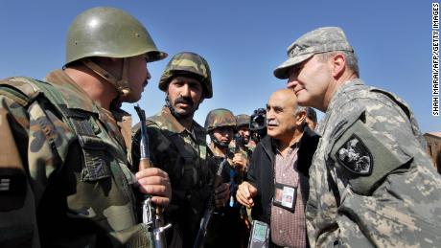
Lt. Gen. Karl Eikenberry, a commander in Afghanistan from 2005 to 2007, speaks with Afghan National Army soldiers at their remote firebase near the Pakistani border in the Barmal district of southeastern Paktika province, in October 2006.
Afghanistan's former ambassador to the US, Roya Rahmani, echoes the charges about political corruption and the army's lack of leadership. She also criticizes Trump administration steps that strengthened the Taliban -- and raises the prospect of a secret deal between Trump and the militant group that might have hastened the Afghan army's collapse.
All the former commanders review mistakes they believe the US made in Afghanistan. All look back at the toll in American blood and treasure.
McChrystal "saw good people with good intentions working hard, but I don't think we did very well. We made a lot of mistakes that we made in prior efforts, like Vietnam and others. And I find that sad as well. We could have done better."
McKiernan wonders aloud whether there were better ways to retaliate for September 11. He concludes that, there are "probably lots of things we could have done differently."

'Soul searching'
McNeill is introspective. "I am doing soul searching to determine -- is it fair to say I did my share of the task?" he asks. "Did I come up short in some way? What's the duty owed to those who came home, not carrying their shields, but on their shields?"
When asked what he would say to Gold Star families or veterans who wonder if the sacrifices of Afghanistan were worth it, McNeill speaks about his pride in everyone who stepped up to fight there or in Iraq before continuing.
"I would just simply say that for what I have failed to do, I'm sorry," McNeill says. "I did the best I could."
Tapper asks why he blames himself.
"The commander is responsible for what his unit does or fails to do," McNeill answers. "If this is a failure, then I carry my share of it."

